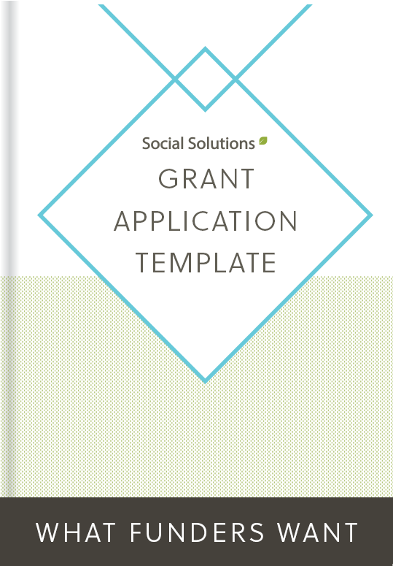

Grant Application Template & Guide

Preface:
Applying for grants can be a daunting task. Many nonprofit leaders go into the grant-writing process asking themselves, “We want to apply for a capacity-building grant, but how do we do that? What are funders even looking for that my nonprofit can provide?"
According to our recent Foundation Reporting Study, foundations and charitable trusts are requiring nonprofit organizations to show how they impact their communities and constituents. The best way to show that impact is through collecting relevant data from your service delivering and reporting on it overtime.
Michael Weinstein, Director of Mission Sales at Social Solutions, explains it as “impact investing”. Instead of simply giving based on mission or location, funders want to actually gauge the change nonprofits are creating in the communities they are investing in. "The only way to be able to gauge that change is to have a tracking system at the nonprofit level that allows [nonprofits] to quantify [their] interactions with clients and see real change over time."
In fact, reporting requirements have risen in the last five years and are only slated to increase in the next five years. So, having robust reporting in place at your organization is essential to proving your impact and gaining more funding. Michael puts it this way - "being able to tell what you’ve done in the past will enable you to get more funding for the future."
Once your nonprofit is ready to apply for funding, it's important to showcase the data you collect and report on to prove that your nonprofit's impact is important, scalable, and something worth investing in.
We wanted to make it as easy as possible for you to get more funding for your organization, so we compiled a grant application template (portions were adapted from Gateway Center for Giving’s Common Application) with some of our favorite, best-practice components and common questions to address during the application process. In this template, you’ll find a short sample grant application and fill in the blank prompts you can use to lay out your organization’s needs in a concise way so you can be well on your way to proving your impact!

Organization Demographic Information
Grantmaker to whom this application is submitted:
Application Date: |  | Org Website:
Applicants Legal Name: (as shown on IRS Letter of Determination)
Doing Business As: (if different from legal name)
EIN #:
Address:
City: |  | State: |  |  | Zip code:
Telephone #: |  | Fax #:
Executive Director:  (or Top Executive) | (Please include prefix and title) | Phone #:
 |  | Email Address:
Main Contact(s) for this Proposal: |  | Phone #:
 |  | Email Address:
Board President: |  | Phone #:
 |  | Email Address:

Applicant’s tax exempt status/ IRS designation (e.g. 501(c)(3), 501(c)(9), etc) | (Attach a copy of the IRS Letter of Determination- NOTE- this is not the state sales and use tax exemption certificate. If there has been a name change provide copies of the amended state certificate of incorporation and amended IRS Letter of Determination)
If not a 501(c)(3) Nonprofit, then who is fiscal agent? | (Attach a copy of the written agreement from fiscal agent plus fiscal agent’s contact information and EIN)

Organization Information
Organization Mission Statement

Summary of Organization’s History
Description of the organization’s current programs, activities, number served annually, and accomplishments. This should be a healthy combination of narrative and data points- while this particular question asks only for number served an outstanding answer will include both outputs and outcomes- what effect was had on the number served?

Proposal Summary
Type of request (check one): Note, not all funders support each type of request. Check with individual grantmaker.
[ ] Capacity Building |  | [ ] Project/Program
[ ] Capital |  | [ ] Other (explain)
[ ] General Operating Support
[ ] New Project | [ ] Existing Project |  | [ ] Expansion of Existing Project

Proposal Summary - In 100 words or less summarize the purpose of this request.
We are conscious of [Target objective to be addressed by this project] and are committed to growing and adapting our center to meet the emerging needs. The [Project Name] will [Intended Outcome].

Program objectives include:

- Objective 1
- Objective 2
- Objective 3

[Organization Name] plays a vital role in the lives of [Target Demographic] in [City, State or Region Area] as evidenced by [Bring in overarching outcomes data here. Be sure to include statistics and concrete data on your organization’s impact].

We believe that this project will introduce [Organization Name] to more people in our community that are in need of services. As a result, we anticipate [Short and Long-term Project Goals].

The total cost of implementation of our [Project Name] is [Funding Amount Your Organization is Requesting].

[Go into price breakdown in this section. For example:

Of this amount, $140,000 has already been committed from both county and city governments and other funders. Your investment of $50,000 will complete the funding we need to fully implement this pilot project.]

We are excited to have the opportunity to work with you. Thank you for your consideration of our request.

Funding Period Requested: (be specific) | / / through / / | Amount Requested: | $
Organization Fiscal Year: |  | Current Annual Organizational Budget: | $
Geographic Area(s) Served:  (include specific counties) | (For this project. If general operations support, for this organization.)

List applicant’s membership of a giving federation: (e.g., United Way, Arts & Education Council, Jewish Federation)

Agreement:

I certify to the best of my knowledge, that all information included in this proposal is correct. The tax-exempt status of this organization is still in effect. If a grant is awarded to this organization, then the proceeds of that grant will not be distributed or used to benefit any organization or individual supporting or engaged in unlawful activities.

In compliance with the USA Patriot Act and other counterterrorism laws, I certify that all funds received from this funder will be used in compliance with all applicable anti-terrorist financing and asset control laws, statutes, and executive orders.

Signature, Executive Director  (or authorizing official on behalf of the organization) |  | Date

Project Information
Needs Statement
What are the community needs or problems to be addressed by this project/organization? Why is this issue important? Be as detailed and specific as possible here.
The main issues that our community in [City, State] community is facing, which we plan on improving, are:

- Issue 1
- Issue 2
- Issue 3

The above issues [Why are they a problem for your demographic?], which affects the entire community.

[Organization Name] has found that [Insert data about the problem you have found. Use statistics about your demographic that highlight what happens when people don’t use your services.].

What are your project goals? Set attainable, measurable goals and make them tie into your overarching organizational goals. Explain how they fit into long-term goals here.
As mentioned above, our main goals are: [Make them relate to organizational efficiency, getting time and resources back, increasing funding opportunities.].

- Goal 1
- Goal 2
- Goal 3

These goals will serve to make [Organization Name] a most effective place to receive service from and more of a community pillar for [City, State].

Who will be served by this grant (describe) and how many will be served? Don’t be too broad here. Target the demographic you think will be affected this most with your project.
If we were to receive this grant, [Organization Name] would use the funds gained to serve [target demographic. We intend to:

- How they will be served 1
- How they will be served 2
- How they will be served 3

With our increased efficiencies, our community will [List a long-term goal here.].

Organization Data and Results
This area is for all data and deliverables.
What other agencies or projects are doing similar work and how are you different? Explain to them why they should invest in YOU. If you have concrete data, add it here.
[Organization Name] is a pillar in the [City, State] community. Our programs have helped [This number] of users in the past [Number] year(s). We have achieved these results by [insert data proving your impact here. This should be based on the data you have collected for the past year.]

[Organization Name] has implemented [Thing that sets you apart from other nonprofits], setting it apart from other organizations in the [City, State] area.

See attached graph and report we have generated to show our organization’s impact on the [City, State] community.

What is your organization’s evaluation process? How do you plan to track and measure the effectiveness of your project/ organization
[Organization Name] will be using [List data management process] to track and measure program and project outcomes. For instance, [name an intake/project management system your organization does very well and have it apply to this project.]

With this method, we will be able to track data overtime and have a consistent system in place to gather results.

How will the evaluation results be used to inform future programming?
By using the data we’ve gained from the consistent reporting process, [Organization Name] will be able to use this data to consistently evaluate our program and project status.

[Explain the process of how you will build on successes.]

[Explain how you will learn from failures or set-backs.]

Our methods allow [Organization Name] to be able to report on outcomes and serve our community in the best way possible.

This guide was created to provide a guideline for answers to common grant questions. To download a full application template for grantmakers or grantseekers, you can find an unmodified version of this template and many more at the Gateway Center for Giving’s website.
http://www.centerforgiving.org/ProgramsEvents/Programs/CommonGrantApplication.aspx

